WCMCAA Community Needs Assessment

This Community Needs Assessment is an overview of the current community conditions in the following Missouri counties: Bates, Benton, Cass, Cedar, Henry, Hickory, Morgan, St. Clair and Vernon.
  - Prepared on: July 18, 2013
Policy Council Approved 8/13
WCMCAA Board Approved 8/13

Contents
WCMCAA Mission Statement
Introduction
Service Locations and Demographics (by County)
Key Findings:
Population Profiles
- Age and Gender
- Number of Households
- Poverty by Household
- Children under the age of 6 in Poverty
- Adults 65+ in Poverty
- Crime Rates
  - Aggravated Assualts
  - Drug Posession and DUI
  - Methamphetamine Incidents
Employment and Income Profiles
- Current Employment
- Unemployment Changes
- Household Income
- Annual Wages
- Living Wage
- Families on TANF
- Food Stamp Participation
Education Profiles
- Infant/Toddler Daycare Costs
- Preschool Costs
- Number of Licensed Facilities
- Adult Literacy Rates
- Adults without High School Education
- First Steps Program for Children
- Count of Early Childhood Services with Disabilities
Health and Nutrition Profiles
- Free and Reduced Lunch Programs
- Women, Infants and Children (WIC) Program
- Public Clinic Immunizations in Percentages
- Low Birth Wieght in Infants
- Child Abuse and Neglect
- Child Deaths Ages 1-14
- Birth Rate to Females Ages 15-19
- Uninsured Populations
- Number of Dental Providers
- Number of Primary Care Providers
- Number of Medicare and Medicaide Providers
Housing Profiles
- Housing Units
- Vacancy Rates
- Foreclosure Rates
- Fair Market Rent

Summary of findings
- Top Four Areas of Challenge

WCMCAA Mission Statement:
West Central Missouri Community Action Agency is dedicated to empowering people to make positive change by coordinating and administering resources.

West Central Missouri Community Action Agency strives to be the voice in our communities and our governments for those in need.

Introduction:
Who Are We and What Do We Do?

In the early 1960’s, a group of citizens representing all strata of society came together to form a nonprofit corporation for the purpose of providing services to better the lives of people in their community. Their shared belief was that the community could best serve its own citizens.
In 1964, President Johnson signed into law the Economic Opportunity Act. The overall purpose of the statute was to eliminate the causes and results of poverty in the United States. Under the Act, a federal Office of Economic Opportunity was established, state Economic Opportunity offices were formed, and new community-based organizations called Community Action Agencies evolved.
In July of 1965, West Central Missouri Rural Development Corporation was designated by the Office of Economic Opportunity as a Community Action Agency (CAA) pursuant to enactment of the Economic Opportunity Act of 1964.
In 1990, the decision was made by the Board of Directors to change the agency’s name from West Central Missouri Rural Development Corporation to include the Community Action designation to more closely identify with the state and national Community Action image and goals. Today, the Agency is known as West Central Missouri Community Action Agency (WCMCAA).
WCMCAA is proud to be a member of the Missouri Association for Community Action, along with the other 19 Community Action Agencies in the state, and the national Community Action Partnership, along with the over 1,000 Community Action Agencies in the nation, and to partner with the National Community Action Foundation.

It is impossible to count the number of lives that have been touched by Community Action. Over the years, WCMCAA has administered a host of programs / services and partnered with West Central Missouri organizations and leaders to improve our communities. Today, WCMCAA offers services in the areas of: Community Development, Community Empowerment, Early Childhood Education, Emergency Assistance, Employment and Training, Energy Assistance, Energy Conservation, Family Support, Family Self-Sufficiency, Health Services, Home ownership, Housing Assistance, Housing / Debt Counseling, Nutrition, and Weatherization.

Agency Program(s) Locations by County:
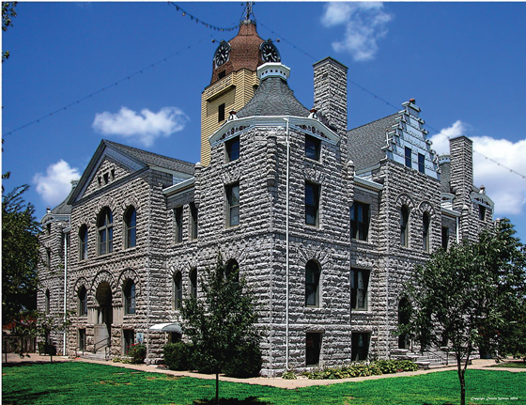
Bates County Court House
Bates County
Estimated Population: 17,008 (2012 Census)
Population Change (2010-2012): -340
Land Area: 836.69 sq. miles
Persons per sq. mile: 20.4
Primary Language: English
Racial and ethnic demographic: 96.8%
Caucasian, 1% Black, 2.2% other
Source Information: U.S. Census; www.quickfacts.census.gov
WCMCAA Services Provided:
Community Services Outreach Office
Energy Conservation; Employment and Training:
5 East Dakota
Butler, Missouri 64730
(660) 679-4108
Fax: (660) 679-0765

Head Start Centers:
Adrian Head Start
311 West 1st Street
Adrian, Missouri 64720
(816) 297-8829

Butler Head Start
225 North Main Street
Butler, Missouri 64730
(660) 679-5046

Rich Hill Head Start
422 North 3rd Street
Rich Hill, Missouri 64779
Women’s Health Services:
Bates County Health Department
501 Orange Street
Butler, MO 64730

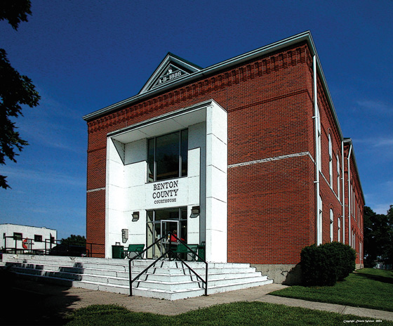
Benton County Court House
Benton County
Estimated Population: 18,962 (2012 Census)
Population Change (2010-2012): -94
Land Area: 704.06 sq. miles
Persons per sq. mile: 27.1
Primary Language: English
Racial and Ethnic demographic: 97.1%
Caucasian, .4% Black, 2.5 other
Source Information: U.S. Census; www.quickfacts.census.gov
WCMCAA Services Provided:
Community Services Outreach Office
Energy Conservation; Employment and Training:
300 Commercial Street
PO Box 726
Warsaw, Missouri 65355
(660) 438-5158
(660) 438-5159
Fax: (660) 438-4471

Head Start Centers:
Warsaw Head Start
800 East Wood Street
Warsaw, Missouri 65355
(660) 438-3773

Women’s Health Services:
In-Home Services
1330 Commercial Suite 203
Warsaw, Missouri 65355
(660) 428-2111
Fax: (660) 438-2711

Women’s Clinic
Benton County Health Department
1220 Commercial St.
Warsaw, Missouri

Housing Services:
Oaktree Villa
919 Walnut Drive #C-2
Warsaw, Missouri 65355
(660) 438-5007
Fax: (660) 438-2116
E-Mail: oaktreevilla@wcmcaa.org

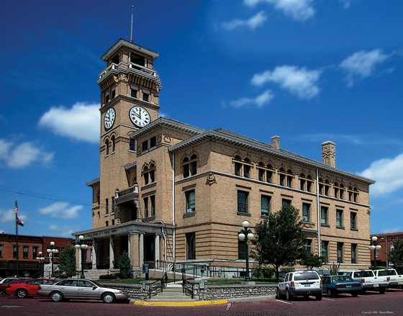
Cass County Court House
Cass County
Estimated Population: 100,376 (2012 Census)
Population Change (2010-2012): +898
Land Area: 696.84 sq. miles
Persons per sq. mile: 142.8
Primary Language: English Secondary: Spanish
Racial and ethnic demographic: 93%
Caucasian, 4.1% Hispanic, 2.9% other
Source Information: U.S. Census; www.quickfacts.census.gov

WCMCAA Services Provided:
Community Services Outreach Office
Energy Conservation; Employment and Training; Women’s Health Clinic:
109 Congress
PO Box 859
Belton, Missouri 64012
(816) 322-0502
(816) 322-0291
Fax: (816) 322-9017

200 North Oakland
PO Box 95
Harrisonville, Missouri 64701
(816) 380-5375
(816) 380-5377
Fax: (816) 380-5275

Head Start Centers:
Belton Head Start
127 Congress
Belton, Missouri 64012
(816) 322-0004
Fax: (816) 322-0007

Harrisonville Head Start
404 Lincoln Road
Harrisonville, Missouri 64701
(816) 380-1844
Fax: (816) 380-1847

Housing Services:
Greenleaf Estates
16805 Spring Valley Road
Belton, Missouri 64012
(816) 331-4620
Fax: (816) 322-2710
E-Mail: greenleafestates@wcmcaa.org

Hawthorn Estates
1900 Jenkins Drive
Harrisonville, Missouri 64701
(816) 380-6833
Fax: (816) 380-3459
E-Mail: hawthornestates@wcmcaa.org

Walnut Estates
412 West Walnut
Raymore, Missouri 64083
(816) 331-2959
Fax: (816) 318-4140
E-Mail: walnutestates@wcmcaa.org

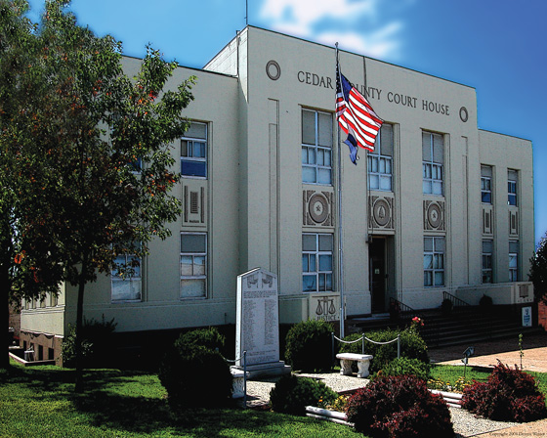
Cedar County Court House
Cedar County
Estimated Population: 13,799 (2012 Census)
Population Change (2010-2012): -183
Land Area: 474.48 sq. miles
Persons per sq. mile: 29.5
Primary Language: English
Racial and ethnic demographic: 97.1%
Caucasian, 1.7% Hispanic, 1.2% other
Source Information: U.S. Census; www.quickfacts.census.gov
WCMCAA Services Provided:
Community Services Outreach Office
Energy Conservation:
720 West 32 Highway
PO Box 953
Stockton, Missouri 65785
(417) 276-3758
Fax: (417) 276-3472

Head Start Centers:
El Dorado Springs Head Start
210 East Fields
El Dorado Springs, Mo. 64744
(417) 876-5895

Stockton Head Start
14246 East 32 Highway
Stockton, Missouri 65785
(417) 276-8332

Housing Services:
Maplewood Estates
1119 South Maplewood Place
Stockton, Missouri 65785
(417) 276-3330
Fax: (417) 276-3338
E-Mail: maplewoodestates@wcmcaa.org

Cedar Ridge
1201 E. Patricia
Eldorado Springs, MO 64744
417-876-6114
FAX 417-876-0065
Email: cedarridge@wcmcaa.org

Henry County Court House
Henry County
Estimated Population: 22,153 (2012 Census)
Population Change (2010-2012): -119
Land Area: 696.95 sq. miles
Persons per sq. mile: 32.4
Primary Language: English
Racial and ethnic demographic: 96.3%
Caucasian, 1.9% Hispanic, 1.2% other
Source Information: U.S. Census; www.quickfacts.census.gov
WCMCAA Services Provided:
Community Services Outreach Office
Energy Conservation; Employment and Training:
1701 N 2nd Street, Suite #19/21
PO Box 99
Clinton, Missouri 64735
(660) 885-5508
Head Start Centers
Clinton Head Start
1003 East Clark
Clinton, Missouri 64735
(660) 885-8568
(660) 885-3764
Fax: (660) 890-6167

Calhoun R-8 School District (Partner Site)
409 South College
Calhoun, Missouri 65323
660-694-3344

Women’s Health Services:
Clinic:
The Christian Church
1201 E. Ohio Street
Clinton, MO 64735

Housing Services:
Antioch Hills
1819 North Gaines Drive
Clinton, Missouri 64735
(660) 885-8200
Fax: (660) 3089
E-Mail: antiochhills@wcmcaa.org

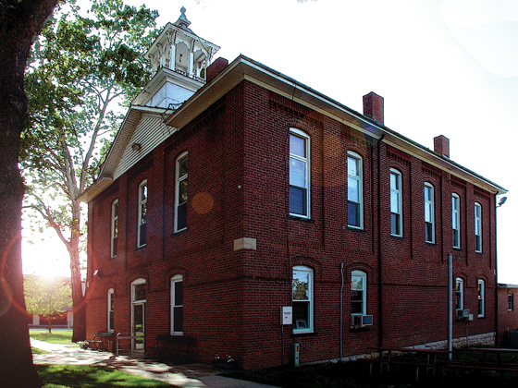
Hickory County Court House
Hickory County
Estimated Population: 9,391 (2012 Census)
Population Change (2010-2012): -236
Land Area: 399.09 sq. miles
Persons per sq. mile: 24.1
Primary Language: English
Racial and ethnic demographic: 96.9%
Caucasian, 1.1% Hispanic, 2% other
Source Information: U.S. Census; www.quickfacts.census.gov
WCMCAA Services Provided:
Community Services Outreach Office; Employment and Training; Energy Conservation:
320 N Main Street
PO Box 188
Wheatland, Missouri 65779
(417) 282-5936
Fax: (417) 282-6966

Head Start Centers
Hermitage Head Start
Route 2 Box 2030
Hermitage, Missouri 65668
(417) 745-6941

Housing Services:
Hickory Estates
701 West Highway 54
Hermitage, Missouri 65668
(417) 745-0131
Fax: (417) 745-0132
E-Mail hickoryestates@wcmcaa.org

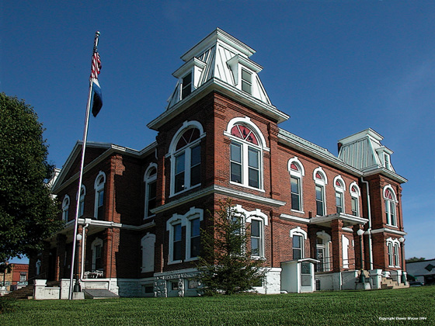
Morgan County Court House
Morgan County
Estimated Population: 20,117 (2012 Census)
Population Change (2010-2012): -448
Land Area: 597.63 sq. miles
Persons per sq. mile: 34.4
Primary Language: English
Racial and ethnic demographic: 96.3%
Caucasian, 1.9% Hispanic, 1.8% other
Source Information: U.S. Census; www.quickfacts.census.gov
WCMCAA Services Provided:
Community Services Outreach Office; Employment and Training; Energy Conservation:
18250 2nd Street
Versailles, Missouri 65084
(573) 378-4432

Head Start Centers
Versailles Head Start and
Early Head Start Home Based
510 South Walnut
Versailles, Missouri 65084
(573) 378-5929

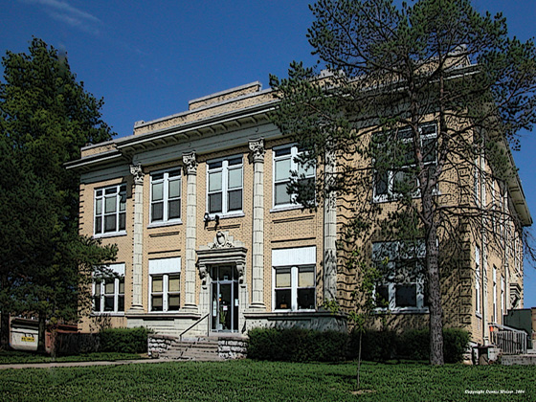
St. Clair County Court House
St. Clair County
Estimated Population: 9,474 (2012 Census)
Population Change (2010-2012): -331
Land Area: 669.98 sq. miles
Persons per sq. mile: 14.6
Primary Language: English
Racial and ethnic demographic: 96.5%
Caucasian, 1.8% Hispanic, 1.7% other
Source Information: U.S. Census; www.quickfacts.census.gov
WCMCAA Services Provided:
Community Services Outreach Office; Employment and Training; Energy Conservation; Women’s Health-Central Office:
106 West 4th Street
Appleton City, Missouri 64724
(660) 476-2185
Fax (660) 476-5529

Head Start Centers
Appleton City Head Start
216 South Beech Street
Appleton City, Missouri 64724
(660) 476-5877
Head Start Home Based – Central Office Contact

Housing Services:
Appleton Estates
300 South Beech
Appleton City, Missouri 64724
(660) 476-2184
Fax: (660) 476-5529
E-Mail: appletonestates@wcmcaa.org

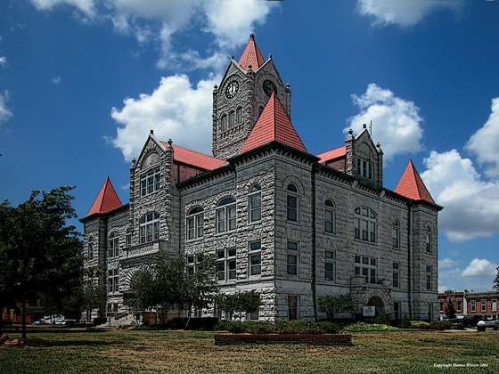
Vernon County Court House
Vernon County
Estimated Population: 20,748 (2012 Census)
Population Change (2010-2012): -411
Land Area: 826.40 sq. miles
Persons per sq. mile: 25.6
Primary Language: English
Racial and ethnic demographic: 96.3%
Caucasian, 1.8% Hispanic, 1.9% other
Source Information: U.S. Census; www.quickfacts.census.gov
WCMCAA Services Provided:
Community Services Outreach Office; Employment and Training; Energy Conservation; Women’s Health
1801 North Osage, Suite A
Nevada, Missouri 64772
(417) 667-5741
(417) 667-5779
Fax: (417) 667-6393
Head Start Centers
Nevada Head Start
1025 East Wooter
Nevada, Missouri 64772
417-667-5393
Fax: 417-667-8890

Women’s Health Services, Women’s Clinic:
Vernon County Health Department
301 N Washington Street
Nevada MO 64722

Key Findings: Population Profiles
Population Profile: Age and Gender
- Age and Gender Demographics from the U.S. Census Bureau Fact Finder:
County | Age 0-4  M/F | 5-9  M/F | 10-14  M/F | 15-19  M/F | 20-64  M/F | Over 65  M/F
Bates | 541/585 | 636/550 | 617/563 | 602/540 | 4,894/4,882 | 1,321/1,698
Benton | 426/400 | 486/440 | 540/507 | 504/505 | 5,331/5,352 | 2,444/2,492
Cass | 3,498/3,258 | 3,684/3,787 | 3,941/3,787 | 3,596/3383 | 29,253/30,350 | 5,925/7,565
Cedar | 428/407 | 483/430 | 517/449 | 459/440 | 3,717/3,831 | 1,421/1,705
Henry | 666/673 | 704/699 | 717/691 | 665/658 | 6,402/6,569 | 1,978/2,367
Hickory | 213/228 | 210/221 | 236/249 | 271/224 | 2,500/2,616 | 1,408/1,438
Morgan | 634/627 | 604/597` | 671/607 | 627/667 | 737/706 | 2,196/2,339
St. Clair | 251/237 | 266/252 | 313/277 | 307/283 | 365/276 | 1,081/1,214
Vernon | 769/695 | 739/671 | 754/709 | 761/854 | 6,007/6,413 | 1,522/1,954
Source Information: U.S. Census Bureau; Fact Finder 2007-2011

- Note the sizable increase in the age group 20-64 from 2007-2012 while the age group over 65 decreased. Most of the nine counties that WCMCAA serves falls under the ‘rural’ category.

Population Profile: Number of Households
The change in the number of households within the nine county area comparison from 2007 to 2010 from the U.S. Census Bureau.
County | Total Households 2000 | Total Households 2010 | Percentage of Change
Bates | 7,247 | 7,842 | 8.2
Benton | 12,691 | 14,150 | 11.4
Cass | 31,677 | 40,030 | 26.3
Cedar | 6,813 | 7,224 | 6
Henry | 10,261 | 10,886 | 6
Hickory | 6,184 | 6,835 | 10.5
Morgan | 13,898 | 15,517 | 11.6
St. Clair | 5,205 | 5,640 | 8.3
Vernon | 8,872 | 9,495 | 7
Source: US Census Bureau, 2010, Population and Housing Unit Counts
Population Profile: Poverty by Household
County | 2007 Poverty Rate | 2011 Poverty Rate | Percentage of Change
Bates | 15.9% | 18.0% | 2.1
Benton | 18.6% | 19.4% | .8
Cass | 7.5% | 10.0% | 2.5
Cedar | 20.0% | 26.7% | 6.7
Henry | 16.8% | 21.1% | 4.3
Hickory | 19.1% | 20.5% | 1.4
Morgan | 18.3% | 19.2% | .9
St. Clair | 21.7% | 20.1% | 1.6
Vernon | 18.9% | 28.4% | 9.5
Source: US Census Bureau, 2007-2011 America’s Fact Finder
The county with the highest increase in poverty rates by household and by children under the age of 6, was in Vernon County, per the US Census. The average poverty rate for counties served in 2011 was 20.3% while the average for the state of Missouri came in at 14.3%

Population Profile: Children under the age of 6 in Poverty

Source: Kids Count Data Center; datacemter.kidscount.org

County | Under age 6 in poverty: 1990 | Under age 6 in poverty: 2007 | Increase/Decrease in poverty numbers
Bates | 315 | 243 | +72
Benton | 245 | 284 | +39
Cass | 848 | 827 | -21
Cedar | 317 | 277 | -40
Henry | 458 | 217 | -241
Hickory | 118 | 171 | +53
Morgan | 297 | 362 | +65
St. Clair | 253 | 209 | -44
Vernon | 360 | 711 | +351
Source: Kids Count Data Center; datacemter.kidscount.org

The increase in poverty for children under the age of six has increased in over half of the counties served. Vernon county rates have doubled.

Population Profile: Adults 65+ in Poverty

Source: Missouri Senior Report and American Community Survey

County | 65+ in Poverty – 2000 | 65+ in Poverty 2008 | Decrease in Poverty Percentages
Bates | 14.1 | 12.6 | 1.5
Benton | 9.6 | 8.6 | 1.0
Cass | 5.2 | 4.7 | .5
Cedar | 14.2 | 12.7 | 1.5
Henry | 13.9 | 12.4 | 1.5
Hickory | 11.0 | 9.8 | 1.2
Morgan | 9.7 | 7.8 | 1.9
St. Clair | 17.6 | 15.7 | 1.9
Vernon | 13.3 | 11.8 | 1.5
Source: Missouri Senior Report and American Community Survey

Population Profile: Crime Rates
Source: Missouri Senior Report, 2009. Per 1,000 persons
Population Profile: Crime Rates
Source: Uniform Crime Reports. Mshp.dps.missouri.gove
The incidents of domestic violence in the counties served are higher than reported. Most of the nine counties do not have shelters in their areas. WCMCAA has noted a direct correlation between the domestic violence rates and the increase in homelessness with the Head Start families served.
Population Profile: Crime Rates Aggravated Assaults:

Source: Uniform Crime Reports. Mshp.dps.missouri.gove

County | Aggravated Assaults 2008 | Aggravated Assaults 2012 | Increase/Decrease
Bates | 46 | 28 | <18>
Benton | 58 | 43 | <15>
Cass | 120 | 108 | <12>
Cedar | 19 | 30 | +11
Henry | 56 | 82 | +26
Hickory | 2 | 3 | +1
Morgan | 84 | 42 | <42>
St. Clair | 10 | 16 | +6
Vernon | 58 | 83 | +25
Source: Uniform Crime Reports. Mshp.dps.missouri.gove
The incidents of violence in Vernon and Henry county parallels the increase in poverty numbers in these counties.

Population Profile: Crime Rates Drug Possession and DUI:
County | Number of Drug Possession Arrests | Number of DUI Arrests | % of Arrests vs. Population
Bates | 146 | 79 | 1.24%
Benton | 41 | 18 | .3%
Cass | 115 | 182 | .3%
Cedar | 10 | 17 | .1%
Henry | 67 | 37 | .4%
Hickory | 15 | 3 | .2%
Morgan | 27 | 43 | .3%
St. Clair | 4 | 9 | .2%
Vernon | 21 | 20 | .2%
Source: Uniform Crime Reports. Mshp.dps.missouri.gove

Source: Uniform Crime Reports. Mshp.dps.missouri.gove

Missouri had been the nation's No. 1 meth-producing state every year from 2003 to 2009 until falling behind Tennessee for one year. http://www.kshb.com/dpp/news/state/missouri/missouri-reclaims-name-of-top-meth-maker-in-united-states#ixzz2a42vBafF
Key Findings: Employment Profiles
Employment Profile: Current Unemployment:
According to the U.S. Department of Labor, in 2013 the overall unemployment rate for the State of Missouri was 6.7%. The chart below outlines the unemployment rate in the nine counties served:

Source: Department of Labor. Missourieconomy.org

Employment Profile: Unemployment Change:

County | Unemployment Rate 2008 | Unemployment Rate  2013 | Increase/Decrease
Bates | 7.2% | 7.2% | 0
Benton | 7.7% | 7% | -.7%
Cass | 5.8% | 6.3% | +.5%
Cedar | 6.7% | 6% | -.7%
Henry | 7.2% | 6.5% | -.7%
Hickory | 9.9% | 11.8% | +1.9%
Morgan | 9.0% | 7.4% | -1.6%
St. Clair | 7.8% | 8.0% | +.2%
Vernon | 5.5% | 4.0% | -1.5%
Source: US Department of Labor, Bureau of Labor Statistics.

Employment Profile: Household Income:
County | Median Household Income ($) 2007 | Median Household Income ($) 2011
Bates | 37,981 | 40,376
Benton | 31,140 | 36,255
Cass | 61,025 | 54,969
Cedar | 32,229 | 30,536
Henry | 34,908 | 38,410
Hickory | 28,840 | 30,049
Morgan | 36,367 | 34,885
St. Clair | 30,283 | 30,098
Vernon | 34,320 | 37,342
Statewide Average | 47,202
Source: US Census Bureau, American Fact Finder 2007-2011.

Employment Profile: Annual Wages:

The average wage for all nine counties served fall below the ‘living wage’ criteria.

Employment Profile: Living Wage (one adult one child) by county:

Source: Poverty in America, Living Wage Calculator, 2012. livingwage.mit.edu
Employment Profile: Families on TANF by County:

Source: Health.mo.gov/data

Employment Profile: Food Stamp Program Participation by County:

Source: DSS Monthly Management Report 2013

According to the data from the US Bureau of Economic Analysis, Missouri’s total personal income rates increased by 2.2%, this still fell below the US increase of 3.0%.

Key Findings: Education Profiles
Education Profile: Infant Toddler Daycare Costs (Licensed Facilities):
County | Infant Care Daily Cost ($) 2007 | Infant Care Daily Cost ($) 2011
Bates | 18.50 | 22.00
Benton | 13.00 | 26.00
Cass | 33.70 | 33.00
Henry | 17.00 | 24.00
Hickory | 22.00 | 22.00
Morgan | 20.00 | 25.00
St. Clair | 18.00 | 17.00
Vernon | 28.00 | No data

Education Profile: Preschool Costs (Licensed Facilities):
County | Preschool Daily Cost ($) 2007 | Preschool Daily Cost ($) 2011
Bates | 16.50 | 20.00
Benton | 13.00 | 22.00
Cass | 25.00 | 28.00
Henry | 13.00 | 17.50
Hickory | 15.00 | 12.00
Morgan | 15.00 | 20.00
St. Clair | 15.00 | 33.00
Vernon | 23.00 | 18.00 (Family not Center)

Education Profile: Licensed Child Care Facilities:

Source: Missouri Department of Health and Senior Services, Early Childhood and Prevention Services. 2012 Child Care Market Survey

Education Profile: Adult Literacy Rates:

Source: US Department of Education. Pbs.org/patchworknation

Education Profile: Percent of Adults Without a High School Education:

Source: Robert Wood Foundation/Obstacles to Health 2009
The US Census identified that the rural areas in the state of Missouri have more than 20% of the population over 25 years of age without a high school education.
Education Profile: First Steps Program for Children 2009-2010:
County | Participation Age 0-1 | % Rate Ages 0-1 | Participation Ages 1-2 | % Rate Ages 1-2 | Participation Ages 2-3 | % Rate Ages 2-3 | Participation All Ages | % Rate All Ages
Bates | 1 | .46 | 8 | 3.86 | 8 | 3.62 | 17 | 2.63
Benton | 1 | .56 | 6 | 3.47 | 7 | 3.63 | 14 | 2.57
Cass | 10 | .73 | 29 | 2.20 | 30 | 2.18 | 69 | 1.69
Cedar | 0 | 0 | 3 | 1.92 | 0 | 0 | 3 | .62
Henry | 2 | .79 | 9 | 3.75 | 9 | 2.97 | 20 | 2.47
Hickory | 0 | 0 | 0 | 0 | 5 | 5.26 | 5 | 2.10
Morgan | 0 | 0 | 1 | .37 | 8 | 2.85 | 9 | 1.11
St. Clair | 1 | .95 | 0 | 0 | 1 | .99 | 2 | .65
Vernon | 1 | .36 | 3 | 1.02 | 7 | 2.31 | 11 | 1.26
Source: Department of Elementary and Secondary Education, Part C Participation Data.

Education Profile: Count of Early Childhood Students (3-5 yrs.) with Disabilities by County 2012:

Source: MO Department of Elementary and Secondary Education, Count of students with disabilities as of December 1, 2012.

Note: The top two disabilities identified in all 9 counties were: Speech Impairments and Developmental Delays.

Key Findings: Health and Nutrition Profiles
Health and Nutrition Profiles: Free and Reduced Lunch Programs for Children:

Source: KIDS Count data center, Annie E Casey Foundation. 2013
Health and Nutrition Profiles: Women, Infants and Children (WIC) Program:

Source: health.mo.gov/data/mica/wicprepost.php

Health and Nutrition Profiles: Public Clinic Immunizations in Percentages:
Location | 2001 | 2002 | 2003 | 2004 | 2005
Bates | 83.7 | 83.7 | 68.4 | 71.0 | 68.4
Benton | 78.2 | 78.2 | 78.8 | 91.8 | 78.8
Cass | 81.0 | 81.0 | 87.5 | 80.8 | 87.5
Cedar | 85.7 | 85.7 | 72.0 | 90.3 | 72.0
Henry | 87.5 | 87.5 | 82.6 | 79.8 | 82.6
Hickory | 84.2 | 84.2 | 66.7 | 85.7 | 66.7
Morgan | 98.9 | 98.9 | 99.0 | 70.2 | 99.0
St. Clair | 78.5 | 78.5 | 73.6 | 81.3 | 73.6
Vernon | 89.6 | 89.6 | 89.2 | 83.5 | 89.2
Source: KIDS Count data center, Annie E Casey Foundation. 2013

Health and Nutrition Profiles: Low Birth Weight Infants:

Source: KIDS Count data center, Annie E Casey Foundation. 2013

Note: There was a documented increase in babies born with low birth rate in all counties with the exception of Bates and Hickory counties.

Health and Nutrition Profiles: Child Abuse and Neglect:
County | Unsubstantiated Abuse Cases | Substantiated Cases
Bates | 89 | 16
Benton | 95 | 34
Cass | 580 | 86
Cedar | 101 | 6
Henry | 90 | 36
Hickory | 33 | 15
Morgan | 91 | 46
St. Clair | 61 | 10
Vernon | 166 | 37
Source: Missouri Children’s Division FY 2012
Note: According to the Children’s Division in regards to the number of Family Assessments and Child Abuse/Neglect per 1,000, Henry, Benton and Cedar County ranked the highest with 55.5%-73.5%.

Health and Nutrition Profiles: Child Deaths Ages 1-14:

Source: KIDS Count data center, Annie E Casey Foundation. 2013

Health and Nutrition Profiles: Birth Rates to Females 15-19:

Health and Nutrition Profiles: Uninsured Populations:

Source: Rural Health Plan 2010-2013. Missouri Department of Health and Senior Services.
Note: Approximately 75% of all Missouri Counties, most of which are rural, have a rate of individuals without insurance greater than the state rate.
Health and Nutrition Profiles: Number of Providers (Dental):

Source: MO Department of Health and Senior Services – Rural Health Plan 2012-2013

Health and Nutrition Profiles: Number of Providers (Primary Care Physicians):

Source: MO Department of Health and Senior Services – Rural Health Plan 2012-2013
Health and Nutrition Profiles: Number of Institutional Medicare and Medicaid Providers:

Source: US Department of Health and Human Services, Provider Services 2008

The number of dental providers is extrememly limited in all but one county served. Of these dental providers less than 1% of the providers accept medicade payments.
The numbers of medicade primary physicians in counties served has shown some increase, but the percentage that accept Medicaid payments still falls well below the need.

Key Findings: Housing
Housing Profiles: Housing Units:

County | 2000 | 2010 | % Difference
Bates | 7247 | 7842 | 8.2%
Benton | 12691 | 14150 | 11.4%
Cass | 31677 | 40030 | 26.3%
Cedar | 6813 | 7224 | 6%
Henry | 10261 | 10886 | 6%
Hickory | 6184 | 6835 | 10%
Morgan | 13898 | 15517 | 11.6%
St. Clair | 5205 | 5640 | 8%
Vernon | 8872 | 9495 | 7%
Source: US Census 2010 Population and Housing Unit Counts

Housing Profiles: Vacancy Rates:

Source: US Department of Housing and Urban Development, Aggregated USPS Administrative Data on Address Vacancies, Fourth Quarter 2008.

Housing Profiles: Foreclosure Rates:

Source: US Department of Housing and Urban Development, Neighborhood Stabilization Program, Foreclosure 2008.

Housing Profiles: Fair Market Rent:
County | One-Bedroom | Two-Bedroom | Three-Bedroom | Four-Bedroom
Benton | $458 | $620 | $914 | $917
Bates | $488 | $660 | $888 | $891
Cass | $632 | $783 | $1,073 | $1,195
Cedar | $440 | $595 | $836 | $919
Henry | $448 | $598 | $847 | $1,041
Hickory | $440 | $595 | $741 | $795
Morgan | $460 | $623 | $776 | $881
St. Clair | $488 | $595 | $741 | $795
Vernon | $453 | $613 | $810 | $819
Source: FY 2013 Fair Market Rent Documentation System. huduser.org/portal/datasets

In Summary:

The top four areas of challenge identified in the Community Needs Assessment:

- According to the US Department of Health and Human Services; almost one in three adults living in rural counties are in poor to fair health. Children rank very high on the list of at-risk populations in regards to health needs not being met. In an effort to address this need one goal will be to work towards coordinating services with existing clinics and Dental providers to meet the needs of the clients/children served in our nine county area. In addressing the need for accessing health care for our clients the following barriers need to be addressed:
  - Insurance barriers both underinsured or uninsured
  - Transportation to the existing providers
  - Financial supports for co-pays and follow up medications as needed.
  - Finding care that is quality and able to identify issues correctly.
- The second area identified in this assessment as being a community concern is finding ways to work on assisting families in overcoming the negative effects of Methamphetamine addiction:
  - Training staff to identify what the indicators are for Meth usage
  - Educating the public on what they can do to report suspected drug use
  - Connecting families with supports who are affected by this epidemic
- The third area identified as one of concern is the need for supports with families affected by domestic violence. The negative effects of domestic violence range from poverty, poor health, homelessness and possible death. A few ways to assist in this effort are:
  - Educating families on ways to remove themselves from a violent home
  - Working with existing shelters to take in those individuals from neighboring counties
  - Educating the staff on what supports are available and what they can do to assist
- Fourth area would be working to reduce the incidents of child abuse and neglect. Ways to possibly address this area could be:
  - Training staff on ways to do early identification of children in crisis
  - Train staff that work with the elderly and adult population on keys for identifying abuse indicators
  - Continue to provide supports and education for families in crisis.

