One Bedroom Apartment Floor Plan
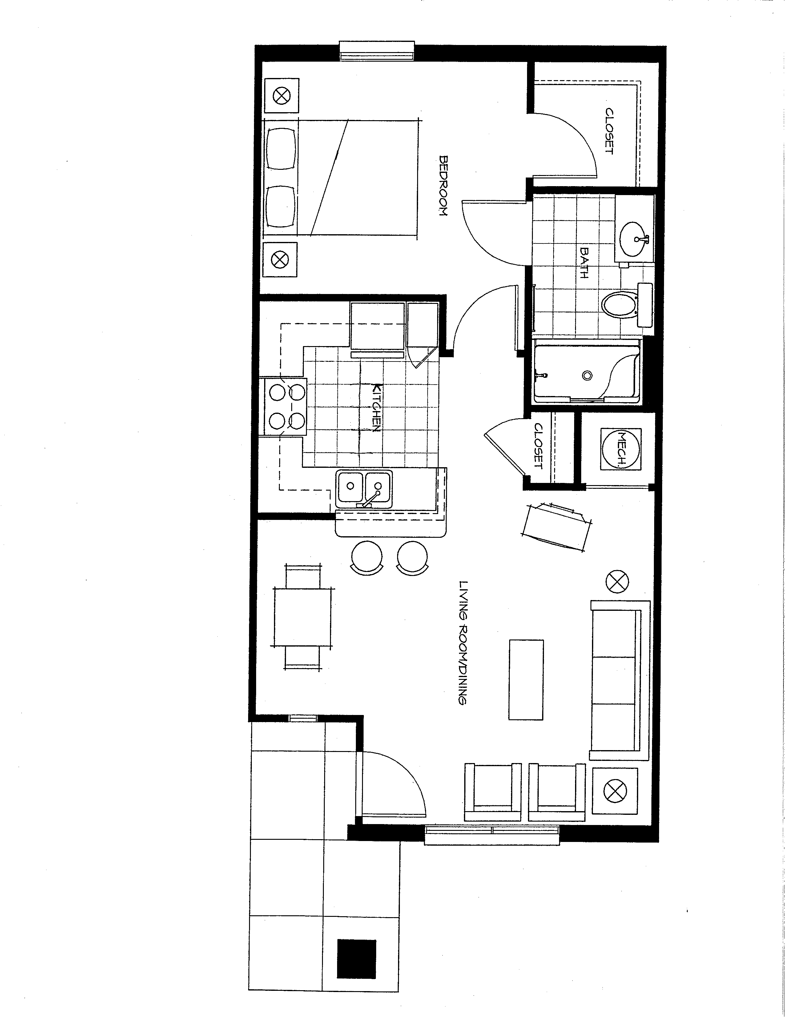
Notes: __________________
________________________
________________________
________________________
________________________
________________________
________________________
Other properties owned and managed by West Central Missouri Community Action Agency:

Antioch Hills • Clinton, MO
(660) 885-8200

Appleton Estates • Appleton City, MO
(660) 476-2185

Cedar Ridge • Eldorado Springs, MO
(417) 876-6114

Greenleaf Estates • Belton, MO
(816) 331-4620

Hawthorn Estates • Harrisonville, MO
(816) 380-6833

Hickory Estates • Hermitage, MO
(417) 745-0131

Oaktree Villa • Warsaw, MO
(660) 438-5007

Prairie Estates • Grandview, MO
(816) 767-1445

Walnut Estates • Raymore, MO
(816) 331-2959

Willow Estates • Kansas City, MO
(816) 350-3134

West Central Missouri

Community Action Agency
106 W. Fourth St.
Appleton City, MO 64724
Phone (660) 476-2185
Fax (660) 476-5299
www.wcmcaa.org

S e n i o r
H o u s i n g

Maplewood Estates
1119 West Maplewood Place
Stockton, MO 65785
(417) 276-3330
maplewoodestates@wcmcaa.org


Maplewood Estates
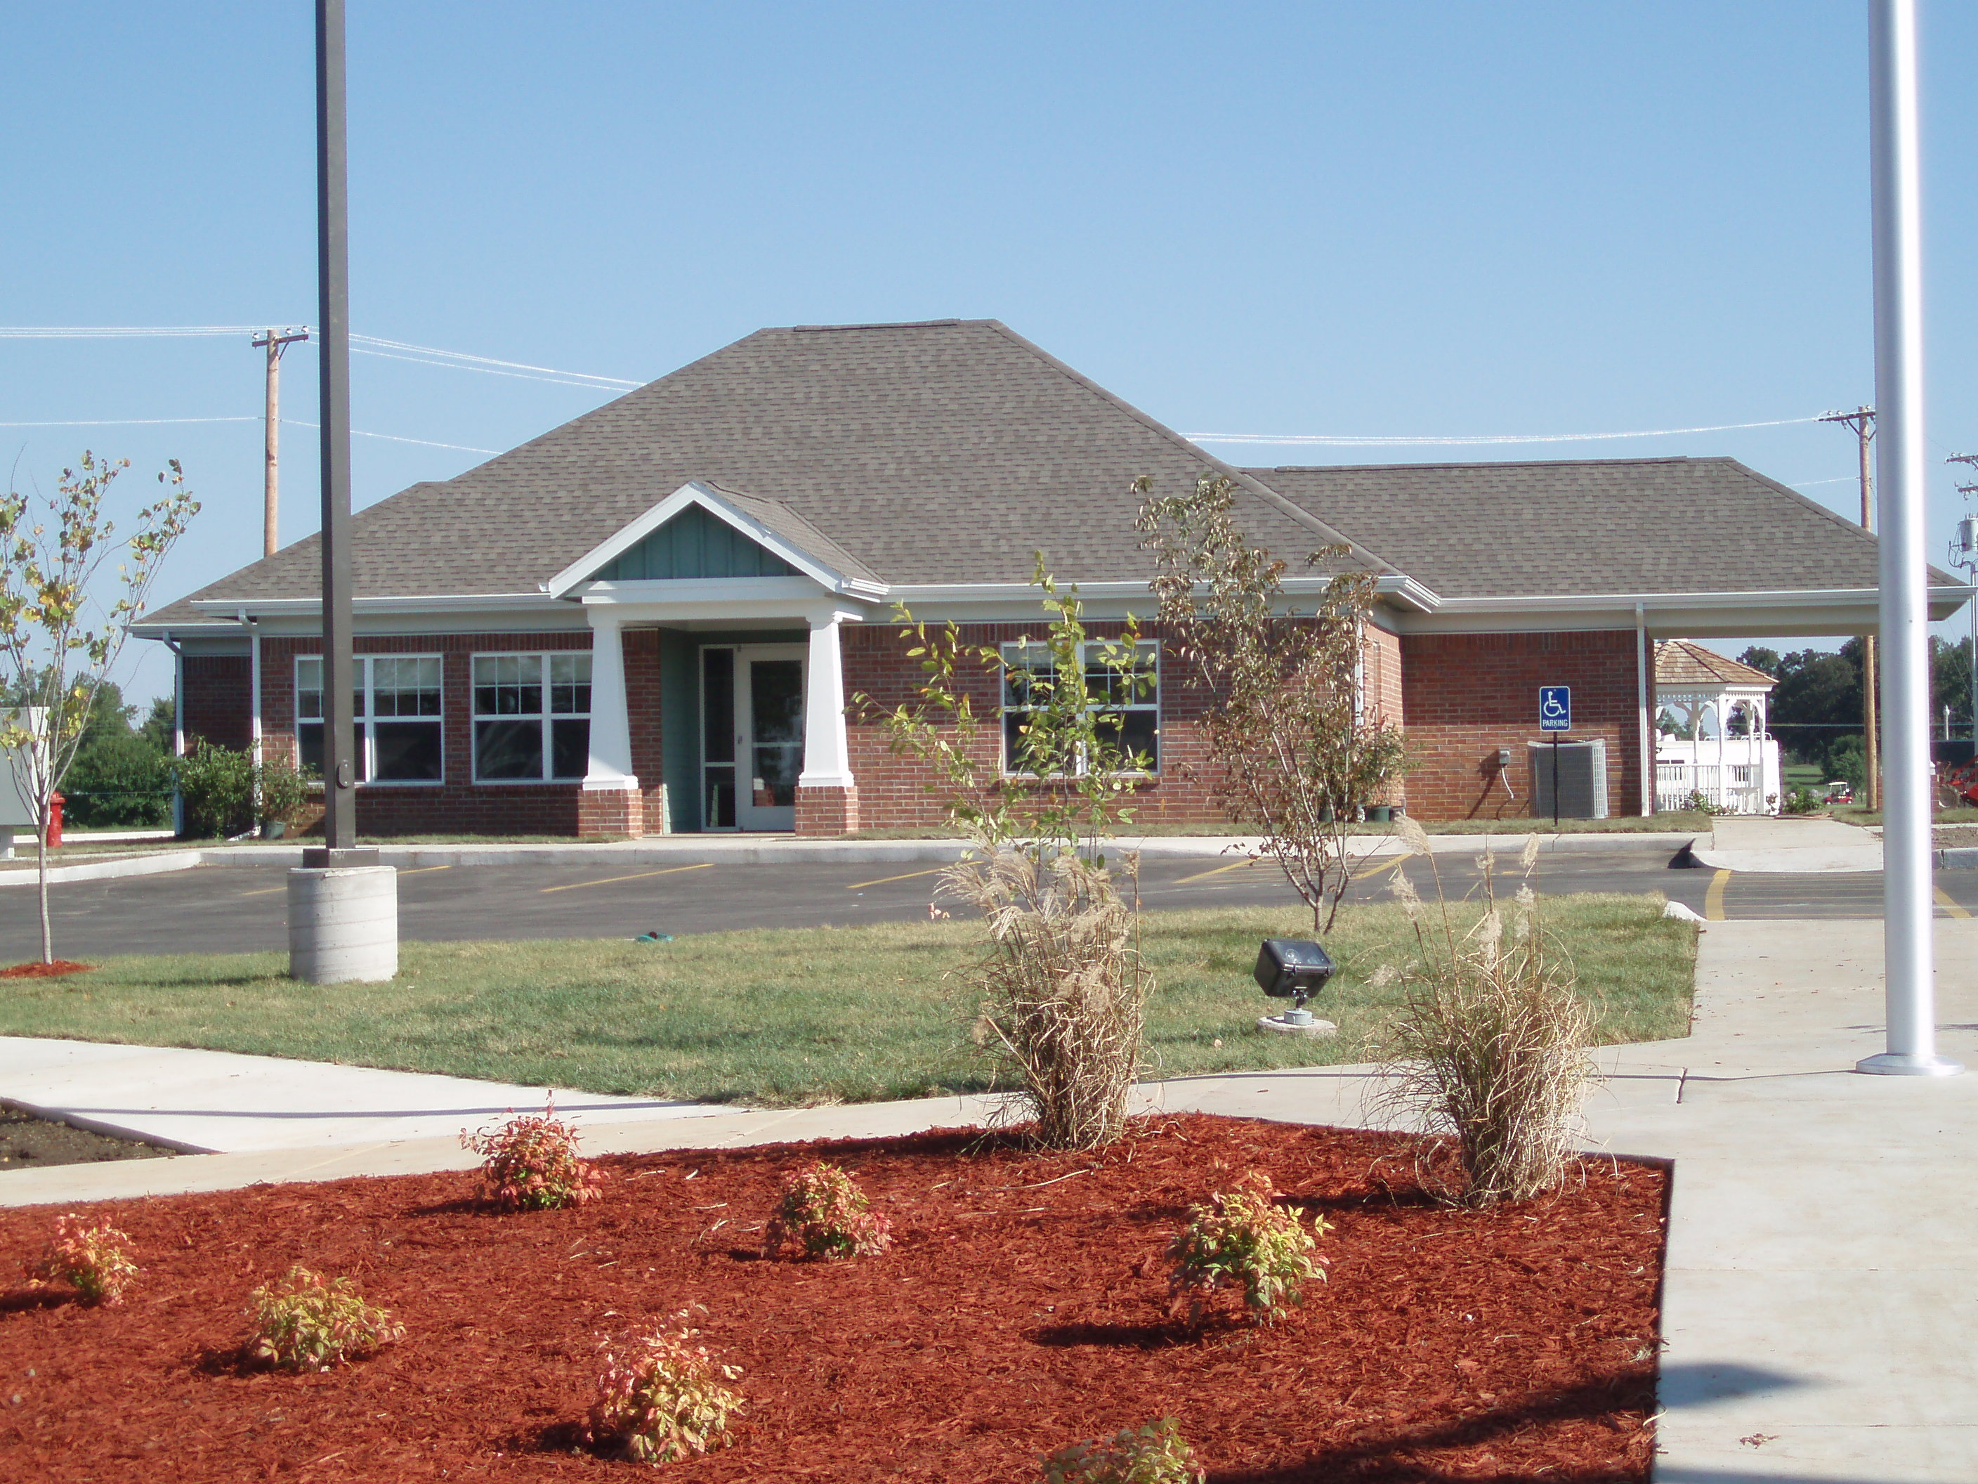
Apartment Homes for Seniors 62 and Older
Come visit us and discover the joy and contentment of living among friends and neighbors.
Maplewood Estates is a perfect blend of Caring, Comfort, and Charm. The community, and all it has to offer, allows our residents to maintain their independence as if still in their own home, but without the time consuming maintenance and expenses of taking care of a house.
Your apartment home is your private haven, where you can entertain family and friends or simply relax. Apartments feature full kitchens, generous closet space, and individually controlled heat and air conditioning. For your convenience, we provide handrails and grab bars in the bathrooms and an emergency alarm system. We welcome pets. You'll have all the comforts of your own home, with none of the responsibilities.

Rent
Tenant portion of rent is figured on 30% of your adjusted income (gross income less medical expenses) minus utility allowance.

Income Limits
Total household income cannot exceed the amounts below:
1 Person $19,350.00
2 People $22,100.00
Square Footage(approx.)
1 Bedroom 537

Location
From Hwy 32 & 39, continue south on Hwy 39 approximately one mile. Turn right at Movie Gallery on to West Maplewood Place.
Apartment Features
Up to 100% Rental Assistance
Utility Allowance
All Maintenance Provided
Stove and Refrigerator Provided
Personal Heating and Cooling Systems
Emergency Alarm System
Outdoor Recreation Area
On-Site Laundry Facility
Locked Mailboxes
Scheduled Monthly Activities
Service Available to Qualified Residents:
Housekeeping
Personal Care
Meals on Wheels
In Home Meal Preparation
Food Pantry /Commodities
On-Site Health Screening
Transportation Services
Medicare/Medicaid Liaison
Financial Management
Social Events
Informational Presentations
Flu Shots
Tax Preparation

