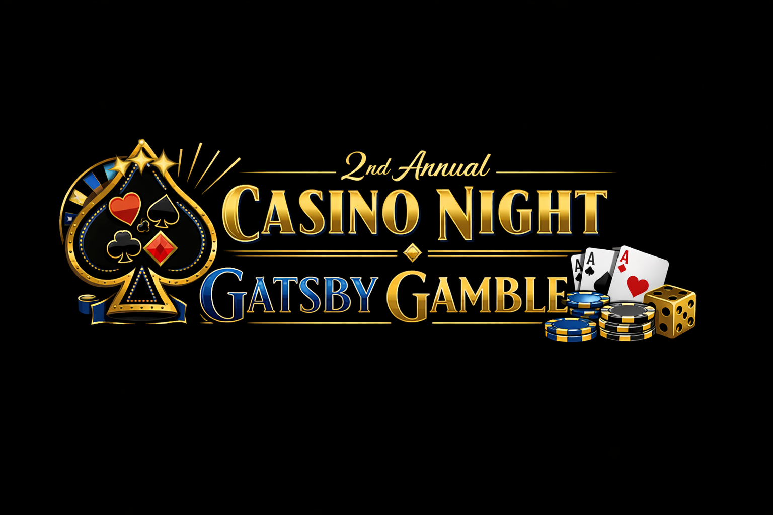
Sponsorship Form
Casino Night proceeds support West Central’s mission of helping individuals & families achieve & maintain safe, stable housing.

Organization/Company/Individual: __________________________________________________________________________________
(Exactly as it should appear on event materials)

Contact Person: ________________________________________________________________________________________________________

Email Address: ____________________________________________________ Phone: __________________________________________

Address: ________________________________________________________________________________________________________________

City/State/Zip: _________________________________________________________________________________________________________

2026 Sponsorship Opportunities

Royal Flush Sponsor – $3,000
•Premium placement in event slideshow •4 Event tickets
•Individual social media spotlight posts •Premium placement in event program •Recognition on casino table marquis during event
High Roller Sponsor – $1,000
•Logo & contact information in event slide show •2 Event Tickets
•Individual social media post •Inside placement in event program
•Recognition on casino table marquis during event
Ace Sponsor – $500
•Logo in event slideshow •Group social media recognition
•Recognition on casino table marquis during event •Logo in event program
Lucky Chip Sponsor – $250
•Name/business listed in event slide show •Group social media recognition
•Recognition on casino table marquis during event •Name/business listed in event program

Other donation amount -- $___________ All donations are appreciated!

Custom Sponsorships – If you would like to sponsor an aspect of the event such as the meal, drink tickets, door prizes, etc. Please call Julie Engeman at 660-476-2185, ext. 1101, or email info@wcmcaa.org. (Recognition varies based on the sponsorship opportunity selected.)

Payment Options:
Enclosed is my payment in the amount of $_______________
(Sponsorships may be tax deductible; please check with your tax advisor.)

Sponsor or donate online at www.wcmcaa.org/donate/, or scan the QR code at the bottom of this page.
Please complete this form & return to: *$250 and above sponsors need to email their logo, too.
WCMCAA, Attn: Gatsby Gamble, 112 W. 4th St., Appleton City, MO 64724. If paid using DONATE NOW, please mail or email the form to info@wcmcaa.org, subject line: Gatsby Gamble.
